Factory Design:  
we create a object without exposing the creation logic

Aitar jonne amra ekta common intereface us korbe.  
like:  
printf er kaj kono kisu show korano  
ai printf onek vabe show hoi  
suppose string , int or any calculation  
amra segula alada alada function create na kore amra   
ekta common class make korlam  
oi common class er againsta   
string , int aigular sub class make korlam aigula common class a abs korlam  
  
  
Jodi printf kotha cinta kori seta holo  
  
ekjon clinet jokhon main function a use kore only printf   
se kintu jane na ai printf er object kivabe arche. Ba clintarnijero obj create kora lagbe na  
  
o sudu keyword ta call korbe  
then seta common interface a jabe then common theke class then subclass

Singleton:

Ekta class er against a ekadhik object thakte parbe na.only ekta thakbe  
oi obj ta ke access krote hole global access point thkabe setar addome access korte parbo

Kno ekta use korbo:

Suppose amar class a database connection ase  
akhon ami new likhe obj joto bar create korbo totobar amar new new connction create hobe.aita onkcostly. Tai aita avoid korar jonne amra signletone usekorbo ekadhik user obj create korte parbe na.

Kivabe kore:  
eitar jonne ekta class nibo oi class ar constructor private kore dibo. Tahole new likhe obj crate korte parbona.oi ekta obj access er jonne satic method ermaddome dkte hobe

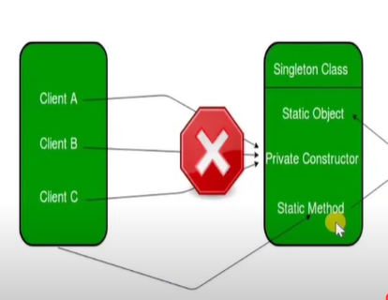

Builder patters:

Ekta obj create korbo oi objectcrate korar jonno je je fnctionlagbe oigla alada alada class make kore then use kora

Stategory- hocche ekta set of algorithom defin kore and jokhon jeta dorkar seta use korte pari

Suppose soting program banabo,  
bubble short and quick short  
age amra obj create korto array te pass kortam then sathe bole ditam bubble  
oi class a if elase deye bola hoto je bubble hole ai function a jao quick holle aro jao  
  
prbm hocche jodi aro addkori tahole if elase bartei thakbe bar bar coding change kora lagbe  
  
  
aitarjonne  
  
amra ekta stategy class defin korbo  
sei class er against sob sroting class banai rakkhbo  
  
clicnt code aami array and stategy pass koredibo  
sei stateg dore sorting kore dibe  
if elase er dorkari porena